KAMPALA JUNIOR ACADEMY
HOLIDAY WORK SET TWO TERM I 2020
PRIMARY FIVE
SOCIAL STUDIES AND RELIGIOUS EDUCATION
Time allowed: 2 hours 15 minutes

Name: ________________________________________________________________

School Name: _________________________________________________________
FOR EXAMINER’S USE ONLY
Read the following instructions carefully:
- The paper has two sections: A and B
- Section A has 40 questions (40 marks)
FOR EXAMINER’S USE ONLY

Qn. No | MARK | SIGN
1 – 10
11 – 20
21 – 30
31 – 40
41 – 43
44 – 46
47 – 49
50 – 52
53 – 55
TOTAL

- Section B has 15 questions (60 marks)
- Answer ALL questions. All answers to both Sections A
and B must be written in the spaces provided.
- All answers must be written using a blue or black ball
point pen or ink. Diagrams should be drawn in pencil.
- Unnecessary crossing of work may lead to loss of marks.
- Any handwriting that cannot be easily read may lead to
loss of marks.
- Do not fill anything in the boxes indicated;
For Examiner’s use only.

Turn over

SECTION A
1. What is natural vegetation?
_____________________________________________________________________
_____________________________________________________________________
2. Name any one crop that grows well in swampy areas. _____________________________________________________________________
3. Give any one problem that is faced by people who live in urban areas in Uganda.
_____________________________________________________________________
4. State any one duty of commercial banks.
_____________________________________________________________________
5. Suggest any one way of controlling soil erosion in mountainous areas of Uganda.
_____________________________________________________________________
6. Which country borders Uganda to the north?
_____________________________________________________________________
7. Name the mountain in Uganda that has snow on its top.
_____________________________________________________________________
8. Why do people cut down trees?
_____________________________________________________________________
9. In which continent do we find Uganda?
_____________________________________________________________________
10. In the space below, draw a map symbol for a bridge.

11. Name the major line of latitude which crosses Uganda.
_____________________________________________________________________
12. Which social service do teachers provide in a community?
_____________________________________________________________________
13. Give one basic need of a family.
_____________________________________________________________________
14. What is a landlocked country?
_____________________________________________________________________
_____________________________________________________________________
15. Give any one traditional way of preserving fish in Uganda.
_____________________________________________________________________
16. What title is given to the traditional leader of Bunyoro?
_____________________________________________________________________
17. Why do sailors need a compass?
_____________________________________________________________________
18. How is democracy practiced at your school?
_____________________________________________________________________
19. Mention the section of police which controls riots.
_____________________________________________________________________
20. How are wild animals dangerous to farmers?
_____________________________________________________________________
21. In which Stone Age period did early man discover fire?
_____________________________________________________________________
22. Name the water way that joins Lake Edward to Lake George.
_____________________________________________________________________
23. Why do tourists go to Bwindi National Game Park?
_____________________________________________________________________
24. Write NEMA in full.
_____________________________________________________________________
_____________________________________________________________________
25. Give one reason why soldiers wear uniforms.
_____________________________________________________________________
26. Give the importance of a rain-gauge in a weather station.
_____________________________________________________________________

The diagram below shows a tool. Study it and answer questions 27 and 28.

27. Name the tool shown above.
_____________________________________________________________________
28. How is the tool above useful in Buganda?
_____________________________________________________________________
29. What are economic activities?
_____________________________________________________________________
_____________________________________________________________________
30. Name the feature on a river where a hydro-electric dam can be built.
_____________________________________________________________________
31. Give any one item that is found in the Uganda museum.
_____________________________________________________________________
32. Name the biggest tribe in Uganda.
_____________________________________________________________________
33. Which highland in Uganda is also known as “Mountains of the moon”?
_____________________________________________________________________
34. Why is it dangerous to live on the slopes of high mountains?
_____________________________________________________________________
35. Give one example of social activities in your district.
_____________________________________________________________________
36. Name one animal which acts as Uganda’s emblem.
_____________________________________________________________________
For each of the questions 37 – 40, answer EITHER a Christian OR Islamic question but not both in a number. Anyone who answers both Christianity and Islam on the same number will not get marks.
37. Either: Name the mother of Jesus Christ.
___________________________________________________________
Or: Name the mother of Prophet Isa.
___________________________________________________________
38. Either: Why were Adam and Eve chased out of Eden?
___________________________________________________________
Or: Why were Adam and Hawa chased out of paradise by Allah?
___________________________________________________________
39. Either: Which book in the Bible tells the story of creation?
___________________________________________________________
Or: Which holy book was revealed to Prophet Dauda?
___________________________________________________________
40. Either: What is baptism as used in Christianity?
___________________________________________________________
___________________________________________________________
Or: What is male circumcision as used in Islam?
___________________________________________________________
___________________________________________________________

SECTION B (60 MARKS)
(Questions 41 to 55 carry 4 marks each)
41. (a) Why is Uganda called a landlocked country?
________________________________________________________________
________________________________________________________________
(b) State any two problems faced by Uganda as a landlocked country.
(i) ________________________________________________________________
(ii) ________________________________________________________________
(c) How is Port Mombasa useful to Uganda’s development?
________________________________________________________________
42. (a) Name any one stone age site.
________________________________________________________________
(b) Give any two importance of Stone Age sites in Uganda.
- ________________________________________________________________
- ________________________________________________________________
(c) Give any one item that we find at a Stone Age site.
________________________________________________________________
43. (a) What is the main use of a scale on a map?
________________________________________________________________
(b) Mention any two types of scale used on a map.
(i) ________________________________________________________________
(ii) ________________________________________________________________
(c) The distance between Wakiso and Kampala is 5cm on the map. Calculate the actual distance between the two places using a scale 1:5km

44. Study the map below and use it to answer the questions that follow.
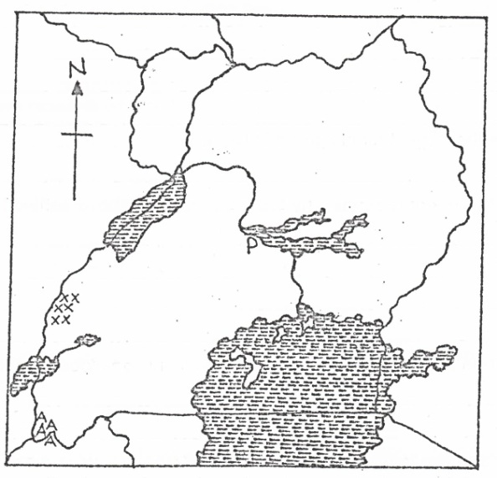
A

N

M

(a) Name the country marked with letter A.
________________________________________________________________
(b) How was the lake marked with letter M formed?
________________________________________________________________
(c) Give the most common crop grown in the region marked xxx.
________________________________________________________________
(d) Why are there many swamps around lake marked N?
________________________________________________________________
45. (a) What are natural resources?
________________________________________________________________
________________________________________________________________
(b) Mention any two examples of renewable resources.
(i) ________________________________________________________________
(ii) ________________________________________________________________
(c) State one value of land to people.
________________________________________________________________
46. (a) What is child abuse?
________________________________________________________________
________________________________________________________________
(b) Give any two causes of child abuse in homes.
(i) ________________________________________________________________
(ii) ________________________________________________________________
(c) Why is a child advised not to move alone from school back home?
________________________________________________________________
47. (a) State any two ways early man obtained food.
(i) ________________________________________________________________
(ii) ________________________________________________________________
(b) Mention any two problems that early man faced.
(i) ________________________________________________________________
(ii) ________________________________________________________________

48. (a) What are voluntary organizations?
________________________________________________________________
________________________________________________________________
(b) Which group of people benefit from UWESO?
________________________________________________________________
________________________________________________________________
(c) Write the following in full.
(i) TASO ___________________________________________________________
(ii) UWESO _________________________________________________________
49. (a) Which human activity has led to the destruction of most forests in Uganda?
________________________________________________________________
(b) Name any two forests found in western Uganda.
(i) ________________________________________________________________
(ii) ________________________________________________________________
(c) Give one product obtained from forests.
________________________________________________________________
50. (a) What name is given to the laws passed by the district councils?
________________________________________________________________
(b) Give one use of laws in a community.
________________________________________________________________
(c) Name the people who provide security in a community.
(i) ________________________________________________________________
(ii) ________________________________________________________________

For each of the questions 51 to 55, answer EITHER the Christian OR Islamic question but not both. No marks will be awarded to a pupil who attempts both alternatives.

51. Either:
(a) Who received the Ten Commandments from God?
________________________________________________________________
- On which mountain did the person above receive the Ten Commandments?
________________________________________________________________
(c) State any one problem which the Israelites faced on their way from Egypt.
________________________________________________________________
(d) Why were the Israelites taken out of Egypt?
________________________________________________________________
Or:
(a) Who received the touret from Allah?
________________________________________________________________
(b) On which mountain was the person above when the touret was revealed to him?
________________________________________________________________
- Why were the Israelites taken out of Egypt?
________________________________________________________________
- State any one problem which the Israelites faced on their way from Egypt.
________________________________________________________________
52. Either:
List the four gospel books in the Bible.
(i) ________________________________________________________________
(ii) ________________________________________________________________
- ________________________________________________________________
(iv) ________________________________________________________________
Or:
Mention the four holy books in Islam.
- ________________________________________________________________
- ________________________________________________________________
(iii) ________________________________________________________________
(iv) ________________________________________________________________
53. Either:
(a) Name the period during which Christians fast.
________________________________________________________________
(b) How many days do Christians fast?
________________________________________________________________
(c) Write any two temptations which the devil gave to Jesus in the wilderness.
(i) ________________________________________________________________
(ii) ________________________________________________________________
Or:
(a) Name the holy month during which Moslems fast.
________________________________________________________________
(b) How many days do Moslems fast?
________________________________________________________________
(c) State any two things that a Muslim is supposed to do during the period of fasting.
(i) ________________________________________________________________
(ii) ________________________________________________________________
54. Either:
(a) After the disobedience of man, state one type of punishment that was given to:
(i) Adam ___________________________________________________________
(ii) Eve ___________________________________________________________
- Serpent (Snake) __________________________________________________
(b) Why did God send Jesus to earth?
________________________________________________________________
Or:
(a) What is ablution?
________________________________________________________________
________________________________________________________________
(b) When can a Moslem perform dry ablution?
________________________________________________________________
(c) Mention any two kinds of water suitable for ablution.
(i) ________________________________________________________________
(ii) ________________________________________________________________
55. EITHER:
(a) Name the apostle who;
(i) denied Jesus three times.
________________________________________________________________
(ii) betrayed Jesus.
________________________________________________________________
(iii) doubted that Jesus had risen.
________________________________________________________________
(b) What title is given to the followers of Jesus Christ?
________________________________________________________________
Or:
(a) Mention any two names given to Allah.
(i) ________________________________________________________________
(ii) ________________________________________________________________
(b) Give any two reasons why we should have faith in Allah.
(i) ________________________________________________________________
(ii) ________________________________________________________________

Good luck

